

***System Provisioning and Configuration Management***

***Submitted by:***

***NAME: Tanishqua Tellakula***

***SAP ID: 500084269***

***Roll number: R120220007***

***Batch: B1(Hons)***

***EXPERIMENT 1***

***Install Terraform on Windows***

*Installing Terraform on Windows requires you to download the correct Terraform package, unpack, and execute it via the*[*CLI*](https://phoenixnap.com/glossary/common-language-infrastructure)*. Follow the instructions below to ensure you do not miss any steps.*

***Download Terraform File for Windows***

*To find the latest version of Terraform for Windows:*

1. *Browse to the*[*Download Terraform*](https://developer.hashicorp.com/terraform/downloads)*page.*

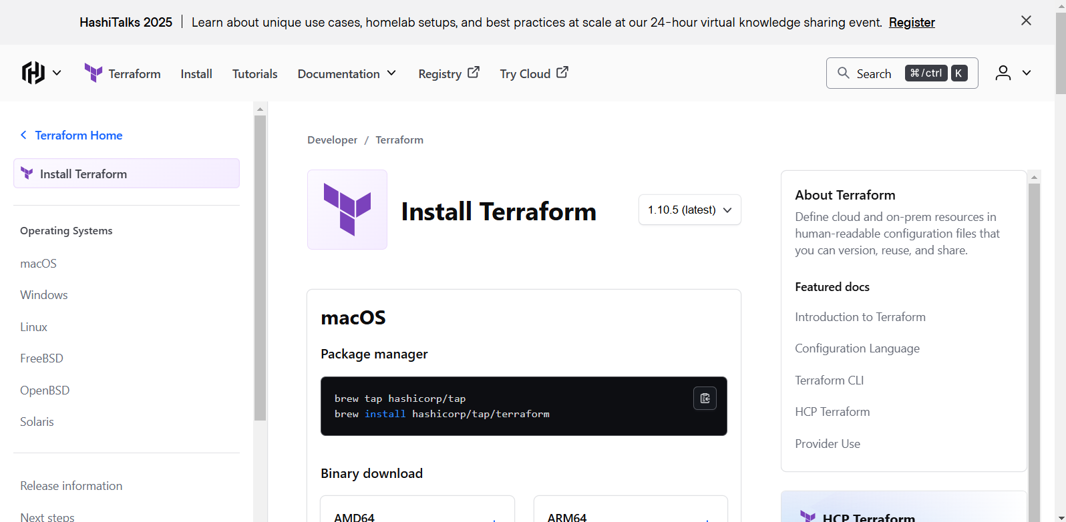

*2. Select the Windows tab under the****Operating System****heading. The latest version is preselected.*

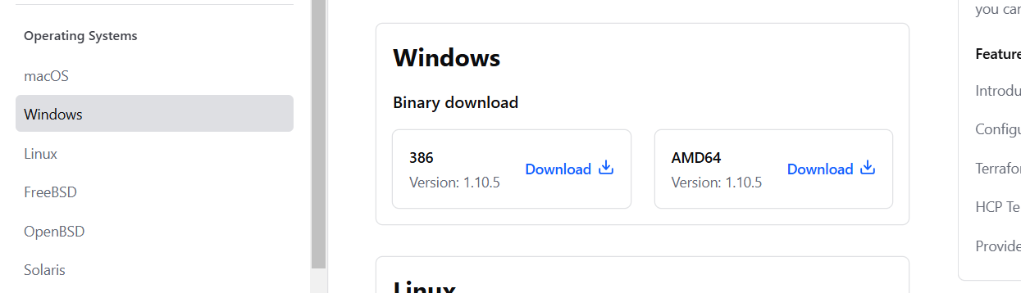

1. *Choose the binary to download. Select 386 for 32-bit systems or*[*AMD64*](https://phoenixnap.com/glossary/amd64)*for 64-bit systems. Choose the download location for the zip file if the download does not start automatically.*

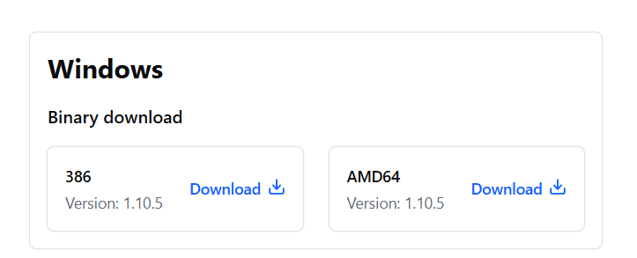

*4. Unzip the downloaded file. For example, use the C:\terraform path. Remember this location so you can add the path to the environment variables.*

***Add Terraform Path to System Environment Variables***

*To add the Terraform executable to the system's global path:*

*1. Open the start menu, start typing environment and click****Edit system environment variables****. The System Properties window opens.*

*2. Click the****Environment Variables...****button.*

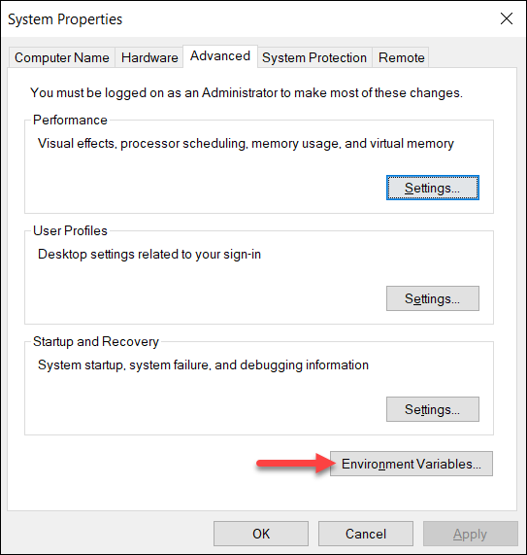

*3. Select the****Path variable****in the System variables section to add terraform for all accounts. Alternatively, select****Path****in the****User variables****section to add terraform for the currently logged-in user only. Click****Edit****once you select a Path****.***

*4. Click****New****in the edit window and enter the location of the Terraform folder.*

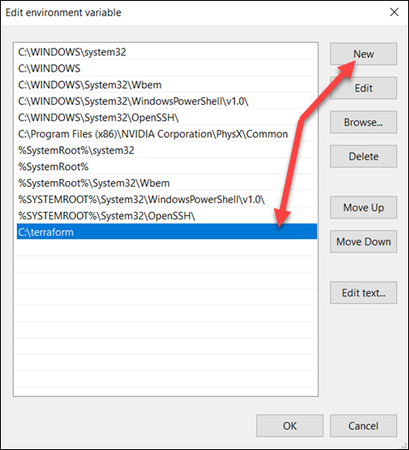

*5. Click****OK****on all windows to apply the changes.*

***Verify Windows Terraform Installation***

*To check the Terraform global path configuration:*

*1. Open a new command-prompt window.*

*2. Enter the command to check the Terraform version:*

| *terraform -version* |
| --- |

*The output shows the Terraform version you downloaded and installed on your Windows machine.*

